**MIS 6309 - Business Datawarehousing**

**Universes**

**Divya Jayaprakash – dxj160830**

**Dimensional Model Based Universe (Universe Design Tool):**

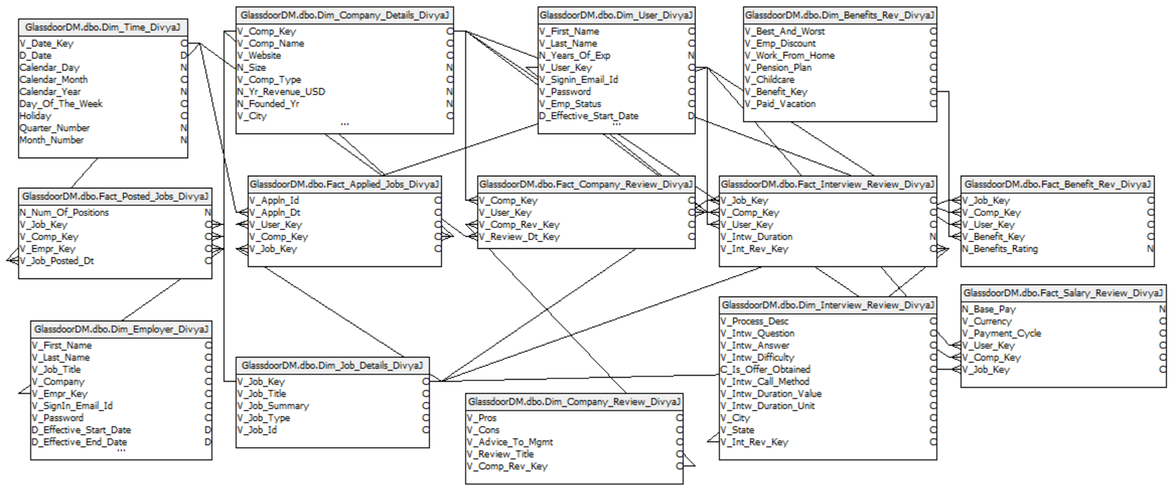

Continued…

**Universe Objects: (UDT)**

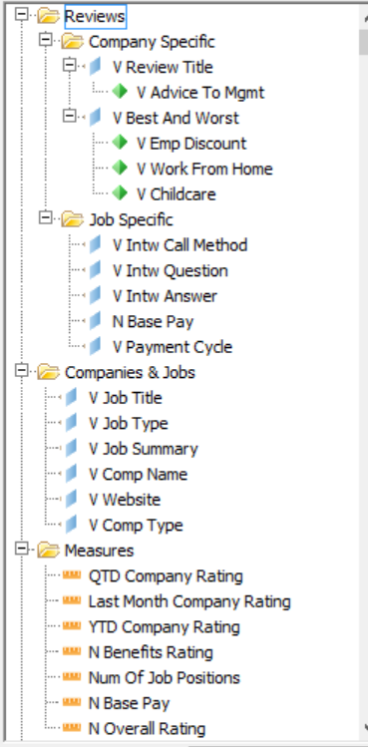 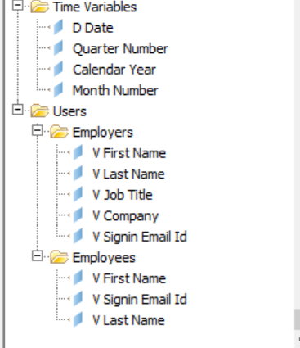

Continued….

**Successful Parsing of the Universe:**

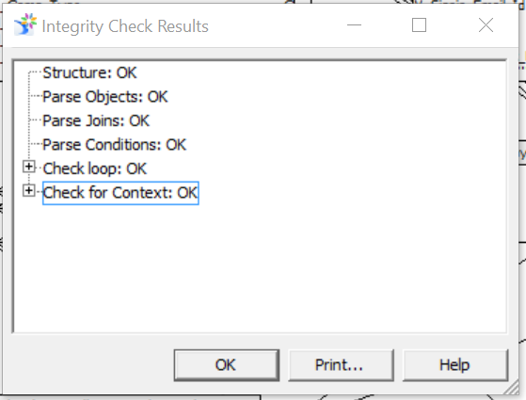

**Calculated fields:**

1. **QTD Company Rating:**

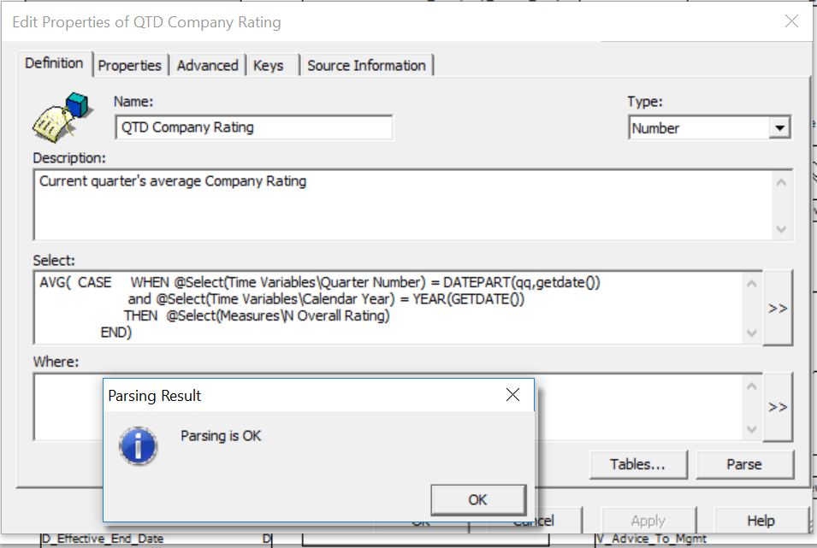

1. **YTD Company Rating:**

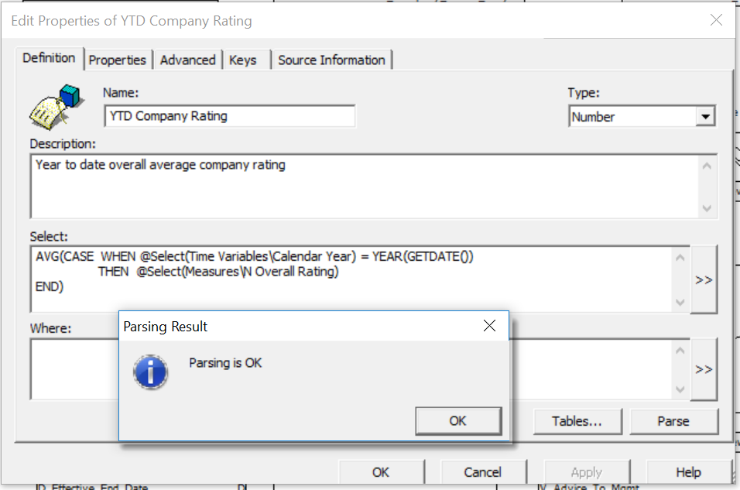

1. **Last Month Company Rating:**

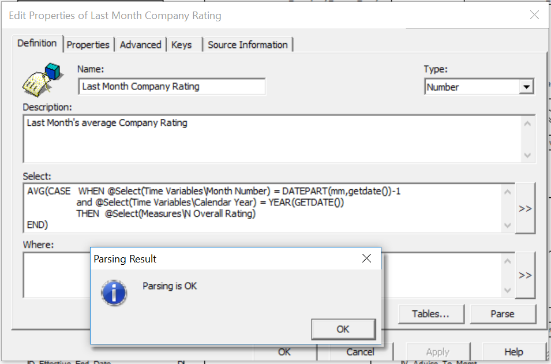

**Calculated Fields Tested in Web Intelligence**

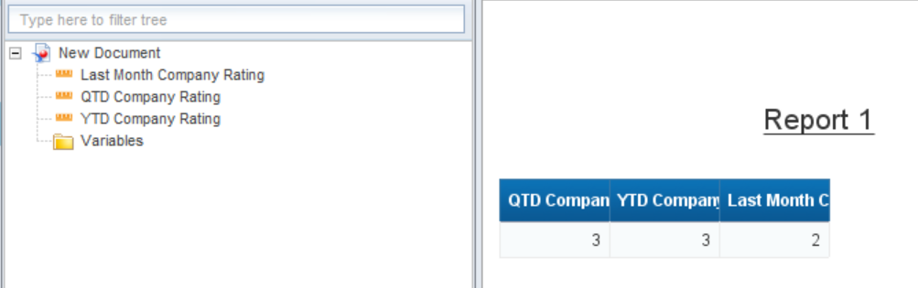

**ER Model Based Universe (Information Design Tool):**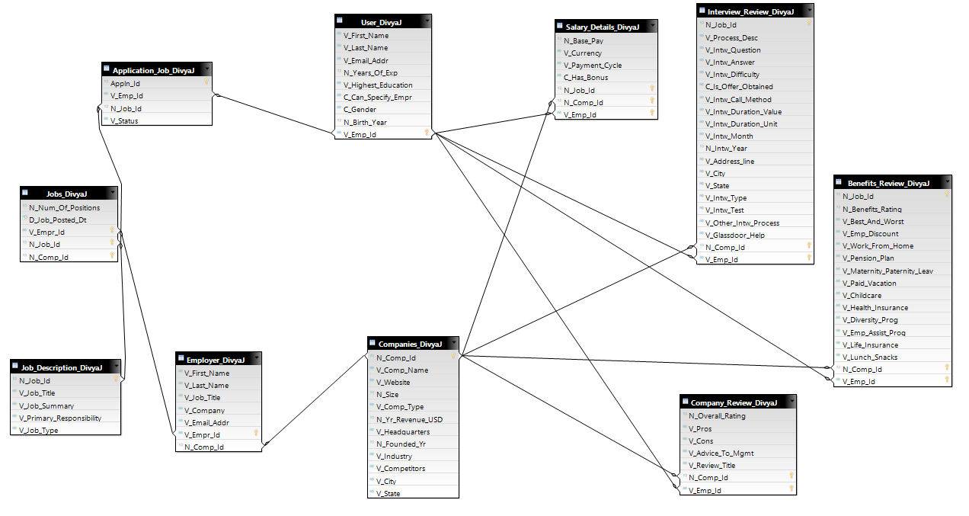

**Universe Objects (IDT):**

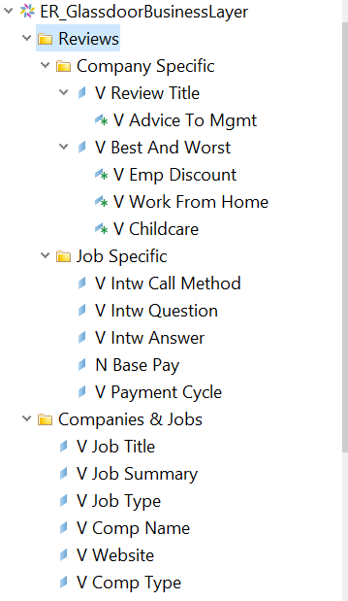 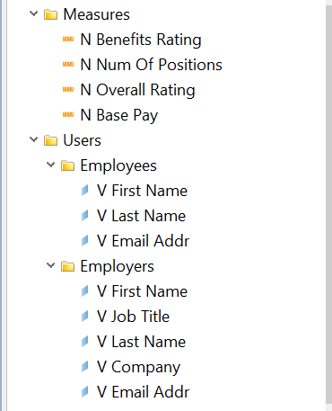

Continued…

**Successful Parsing Of the ER Universe in IDT:**

